

**2015-2016**

**Sunshine State Young Readers**

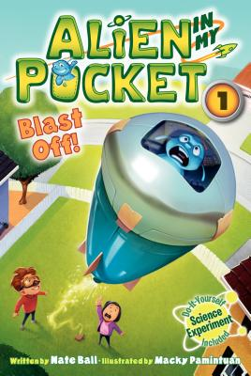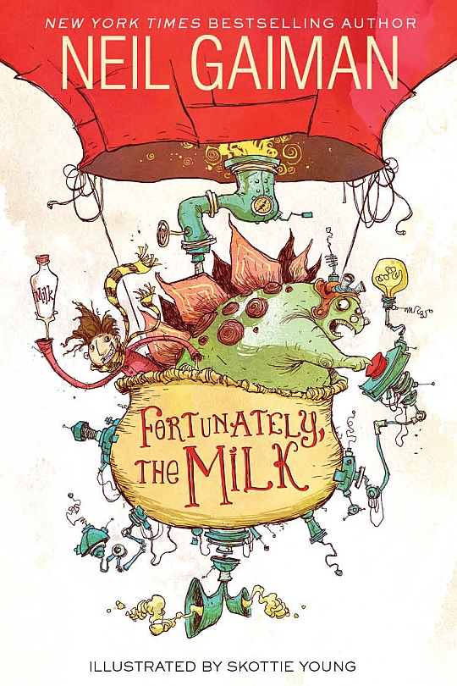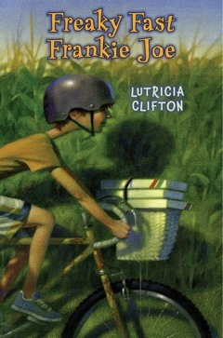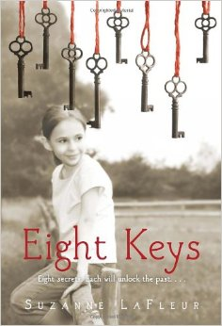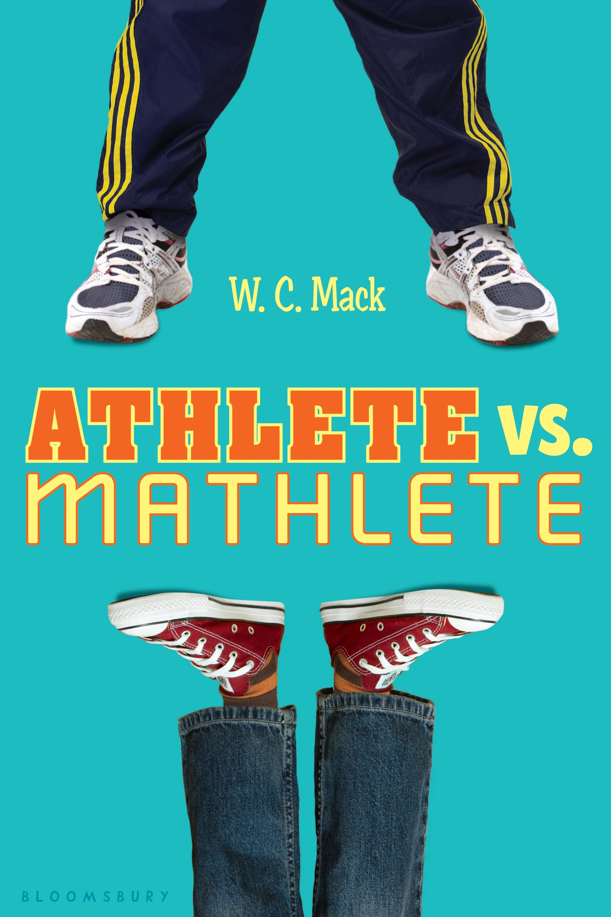

*Alien in My Pocket #1: Blast Off!*

By: Nate Ball

RC: 6 points

*Freaky Fast Frankie Joe*

By: Lutricia Clifton

RC: 11 points

*Fortunately,*

*The Milk*

By: Neil Gaiman

RC: 4 points

*Eight Keys*

By: Suzanne LaFleur

RC: 11 points

*Athlete vs. Mathlete*

By: W.C. Mack

RC: 10 points

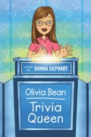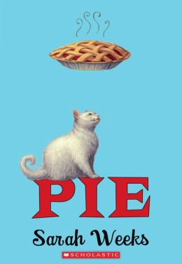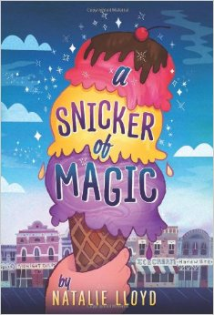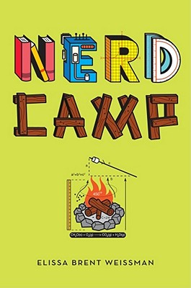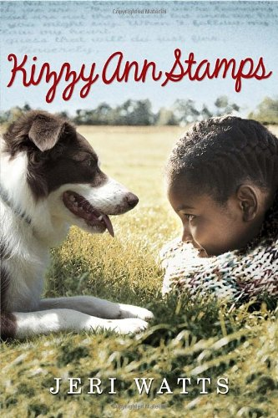

*A Snicker of Magic*

By: Natalie Lloyd

RC: 15 points

*Pie*

By: Sarah Weeks

RC: 9 weeks

*Olivia Bean Trivia Queen*

By: Donna Gephart

RC: 11 points

*Nerd Camp*

By: Elissa Brent Weissman

RC: 10 points

*Kizzy Ann Stamps*

By: Jeri Watts

RC: 11 points

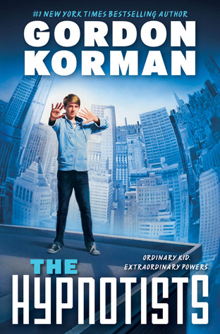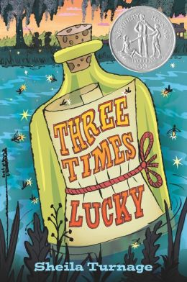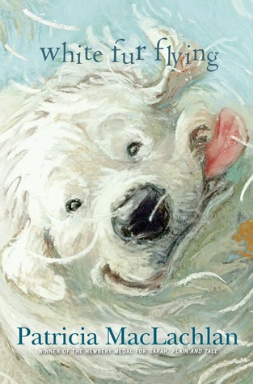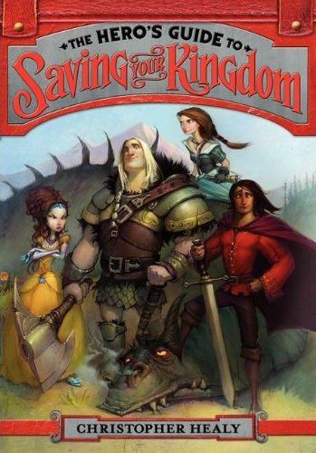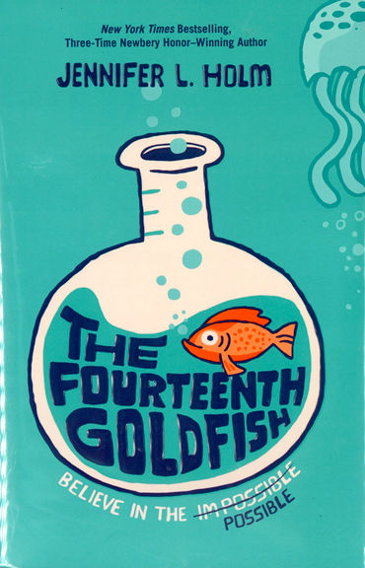

*The Hero’s Guide To Saving Your Kingdom*

By: Christopher Healy

RC: 19 points

*The Hypnotists*

By: Gordon Korman

RC: 14 points

*Three Times Lucky*

RC: 16 points

*White Fur Flying*

By: Patricia MacLachlan

RC: 5 points

*The Fourteenth Goldfish*

By: Jennifer L. Holm

RC: 7 points