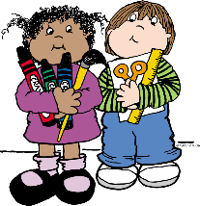

**NEW RIVER ELEMENTARY**

**2017-18 Kindergarten Supply List**

* **Backpack with child’s name on it**
* **1 package of #2 pencils**
* **4 boxes of crayons (24 count or less)**
* **24 glue sticks**
* **1 pair of Fiskars scissors**
* **1 one-inch hard cover 3-ring binder with pockets**
* **2 boxes of Kleenex**
* **2 bottles of hand sanitizer with pump**
* **2 packages of baby wipes**
* **1 roll of paper towels**
* **1 ream of copy paper**

**Wish List Items**

* **Package of plastic or paper cups**
* **Package of white paper plates**
* **Package of dry erase markers**
* **Box of QUART size ZIPLOC bags**
* **Box of GALLON size ZIPLOC bags**

**\* Additional supplies may be requested by teachers at the beginning of the year.**

**\*\*Please DO NOT LABEL supplies. They are used for the class community.**

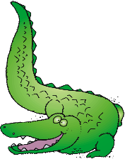

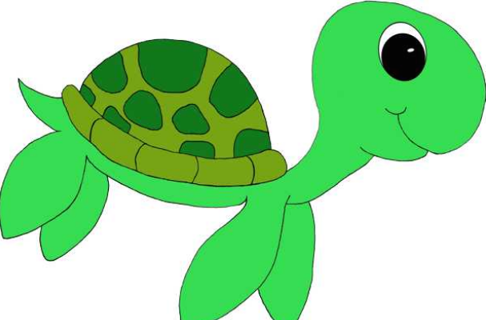1st Grade Supplies

**4 packages of No. 2 pencils**

**2 boxes of Crayola crayons (24 count)**

**2 package of dry erase markers**

**1 package of Fine tip and 1 package of chisel tip**

**2 packages of glue sticks (Elmer’s if possible)**

**4 plastic pocket folders w/3 prongs**

**(Red, Blue, Green, Yellow)**

**4 composition notebooks (solid colors)**

**2 Rolls paper towels**

**1 package of pink pearl erasers**

**1 pair of Fiskars scissors**

**Optional:**

**2 packages of baby wipes**

**2 bottles of hand sanitizer**

**1 box of Band-Aids**

**2 boxes of Kleenex**

**2 boxes of magic erasers**

**1 container of cleaning wipes**

**1 box of Ziploc Baggies (gallon or quart)**

Please bring in the following supplies on the day of registration OR the first day of school. We ask that you **DO NOT** put your child’s name on the items, as everyone will have “community use” of these materials.

New River Elementary

2nd Grade

Supply List

Please bring in the following supplies on the day of registration OR the first day of school. We ask that you **DO NOT** put your child’s name on the items as everyone will have “community use” of these materials.

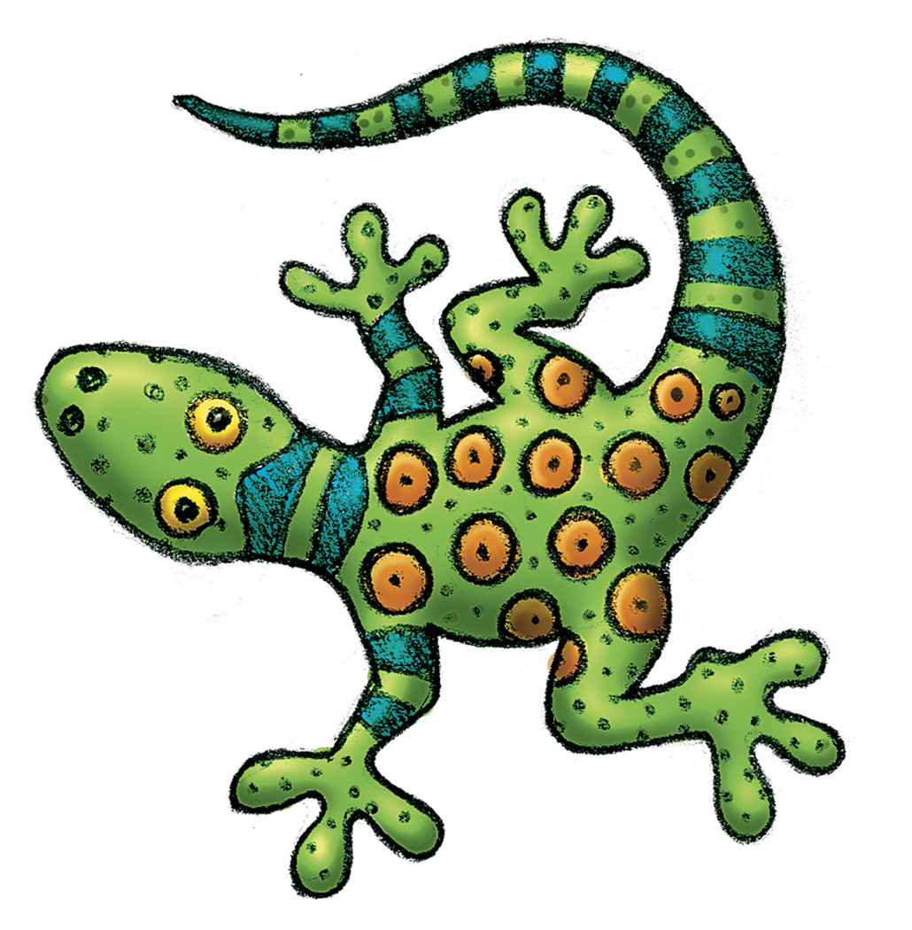

4 packages of No. 2 pencils

4 boxes of Crayola crayons (24 count)

1 package of Expo dry erase markers (chisel tip)

20 glue sticks (Elmer’s if possible)

4 composition notebooks (solid colors) **NOT spiral**

4 (1 blue, 1 red, 1 green, 1 yellow **3-prong plastic folders**)

2 rolls paper towels

2 reams copy paper

1 pair of Fiskars scissors



1 packages of baby wipes

4 boxes of tissues

2 packages Pink Pearl erasers (please no pencil top erasers)

1 package of highlighters

**Wish List**

3x3 post-its

1 package of fine tip dry erase markers

1 bottle of hand sanitizer

1 box of Ziploc baggies (gallon or quart)

1 package magic erasers

**New River Third Grade Supply List**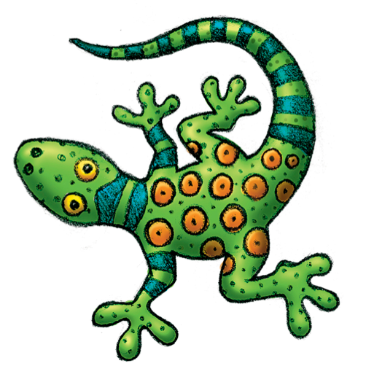

**Needed Supplies**

8 packages of No. 2 pencils (yellow only- no patterns please & no mechanical)**\*\***

Pencil top erasers

2 package of dry erase markers

1 package of washable markers

1 package of crayons

10 glue sticks (Elmer’s if possible)**\*\***

10 pocket folders **with 3 prongs** (plain red, green, yellow, blue are preferred!)

5 **single subject W I D E-ruled** spiral notebooks (plain red, green, yellow, blue are preferred!)**\*\***

3 composition notebooks (black/white or solid colors)

3 reams of copy paper

3 boxes of tissues

2 boxes Ziploc bags: quart or gallon (no snack size)

**Optional Supplies**

1 pair of Fiskar scissors

Plastic sheet protectors

Hand sanitizer

Paper towels

Magic erasers

**\*\*Extras of these items are always appreciated!**

Please bring in the following supplies on the day of registration OR the first day of school! **We ask that you DO NOT put your child’s name on these items, as everyone will have “community use” of these materials.**

NEW RIVER ELEMENTARY

4th Grade Supply List

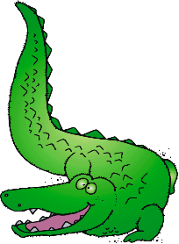

Needed Items

3 dozen #2 pencils

1 package of pencil top erasers

1 pair Fiskars scissors

1 pencil pouch (pouch preferred over boxes)

6 plain colored spiral notebooks

12 glue sticks

3 boxes of tissues

1 bottle hand sanitizer

5 folders WITH PRONGS (plastic folders last longer)

2 reams of copy paper

12 dry erase markers

2 packages of notebook paper

1 1-inch three ring binder

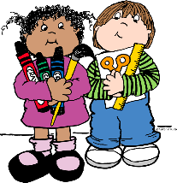

Wish List Items

Markers

Crayons

Paper Towels

Index Cards

Cleaning wipes

Magic Erasers

NEW RIVER ELEMENTARY

5th Grade Supply List

1 book bag

1 1inch 3 ring binder



6 packs wide ruled notebook paper

*2 packs of printer paper

*3 dozen #2 pencils

*2 pkg pencil top erasers

1 pair Fiskars scissors

1 pkg markers or colored pencils

*10 WIDE rule spiral notebooks (3 blue, 2 yellow, 3 red, 2 green)

2 composition books

1 package of highlighters (multicolor)

12 glue sticks

8-10 Dry Erase Markers

10 folders WITH PRONGS (plastic folders will last longer)

(2 of each: blue, yellow, green, red and a

choice color)



*2 packages sanitizing wipes

*2 bottles hand sanitizer

1 box of quart size ZIPLOC baggies

1 box of gallon size ZIPLOC baggies

*3 boxes of tissues

*2 rolls of paper towels

*extras are appreciated

IGUANAS SUPPLY LIST (ESE Classes) K-5

1 Backpack with child’s name on it (no rolling backpacks)

2 Packages Expo Markers

1 Box of Ziploc Bags Gallon Size

1 Box of Ziploc Bags Sandwich Size

1 Box of Ziploc Bags Quart Size

2 Packages of Baby Wipes/Flushable Wipes

3 Three Prong Plastic Folders with Pockets

1 Pair of Fiskars Scissors

4 Glue Sticks

2 Boxes of Tissues

3 Black and White Composition Notebooks (for grades K-2 Primary)

3 Single Subject Notebooks (Intermediate 3-5)

2 Paper Towels

3 Boxes of Crayons (24 count or less)

1 Package of Washable Markers

1 Package of Colored Pencils 12 Count

2 packages #2 pencils

2 Hand Sanitizers

2 Packages of White Copy Paper

1 Box of Bandaids

IGUANA WISH LIST

1 Magic Erasers

Modeling Clay/Play-Doh for Fine Motor Skills

1 Package of Sharpie Markers

**Please do not label supplies, they are used for the class community.