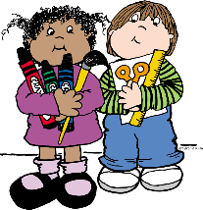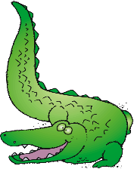

**NEW RIVER ELEMENTARY**

**First Grade Supply List**

**1 Backpack with child’s name on it (no rolling backpacks)**

**1 Pkg #2 pencils**

**3 Boxes of Crayons (24 count or less)**

**1 Box of thick markers**

**1 Pair of Fiskar scissors**

**20 Glue sticks**

**2 Black & White Primary Composition books**

**2 Boxes of kleenex**

**1 Bottle of Germ X/ Purell Hand sanitizer**

**1 Package of Baby wipes**

**3 PLASTIC 3 prong folders w/pockets**

**1 Roll of Paper Towels**

**1 Box of GALLON/QUART/ SNACK size Ziploc**

**bags**

**1 Ream of Copy paper**

**Wish List Items**

**1 Package of plastic or paper cups**

**1 Package of paper plates (large/small)**

**2 Packages dry erase markers**

**1 Package of Sharpie markers**

**\* Additional supplies may be requested by particular teachers at the beginning of the year.**

**\*\*Please do not label supplies, they are used for the class community.**