New River Elementary
2nd Grade
Supply List
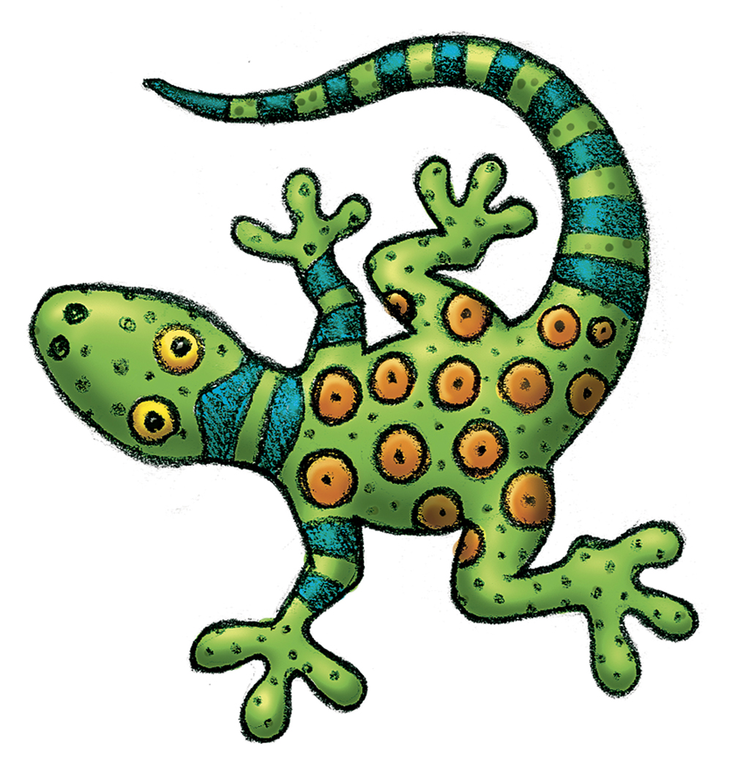
2 packages of No. 2 pencils
1 box of Crayola crayons (24 count)
1 box of Crayola washable markers (8 count)
1 box of colored pencils (12 count)
1 package of dry erase markers (4 pack)
4 glue sticks (Elmer’s if possible)
1 pack of wide-ruled notebook paper
6 pocket folders w/ 3 prongs (different solid colors)
1 white 1” binder
2 single subject –spiral notebooks (solid colors)
3 composition notebooks (solid colors)
1 pencil box (storing crayons, markers, etc. in desk)
1 roll of paper towels
1 ream copy paper

Optional Donations
2 packages of baby wipes
2 bottles of hand sanitizer
2 boxes of band-aids
4 boxes of tissues
1 box of Ziploc baggies (gallon or quart)
1 pair of Fiskars scissors
1 pkg magic erasers
1 roll fancy duct tape

Please bring in the following supplies on the day of registration OR the first day of school. We ask that you DO NOT put your child’s name on the items as everyone will have “community use” of these materials.
Thank-you!

