New River Elementary 3rd
Supply List
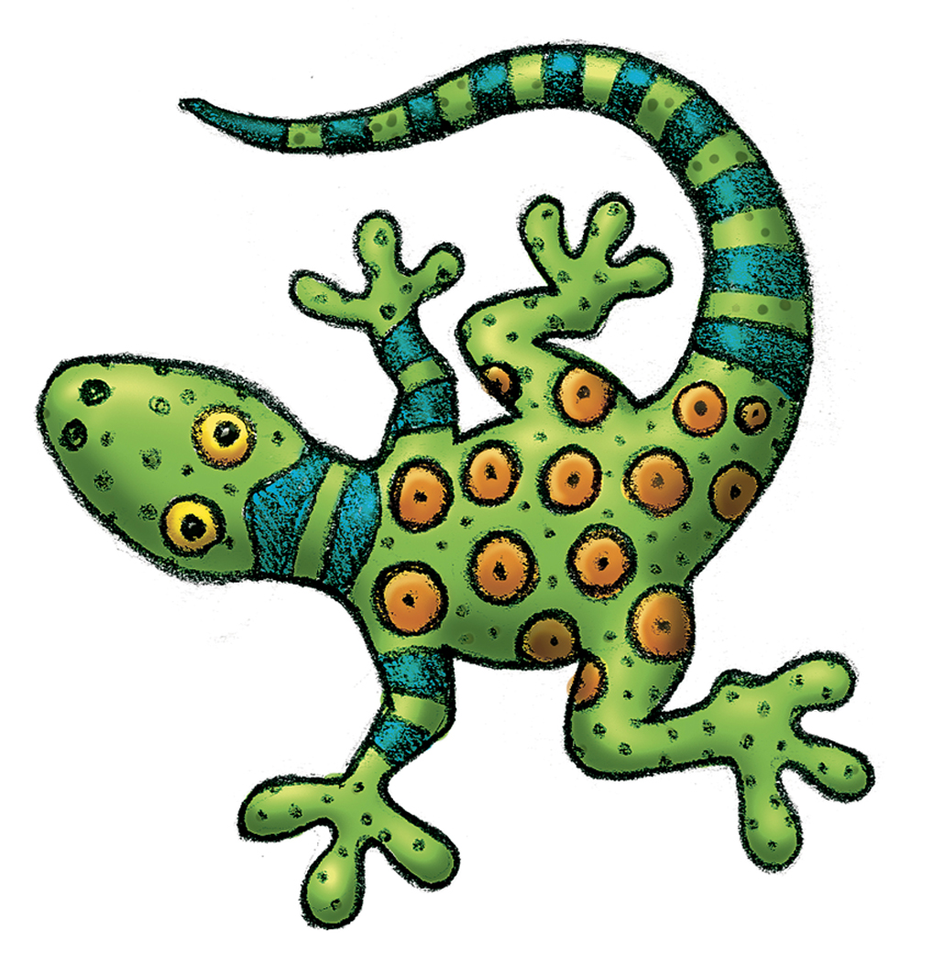
2 packages of No. 2 pencils
1 box of Crayola crayons (24 count)
1 box of Crayola washable markers (8 count)
1 box of colored pencils (12 count)
1 package of dry erase markers (4 pack)
8 glue sticks (Elmer’s if possible)
12 pocket folders w/ 3 prongs (different solid colors)
2 white 1” binder
5 single subject –spiral notebooks (solid colors)
5 composition notebooks (solid colors)
1 pencil box (storing crayons, markers, etc. in desk)
2 Rolls paper towels
1 ream copy paper
1 ruler

Optional Donations
2 packages of baby wipes
2 bottles of hand sanitizer
1 box of band-aids
2 boxes of tissues
1 box of Ziploc baggies (gallon or quart)
1 pair of Fiskars scissors
1 box of pencil top erasers
1 pkg Magic Erasers

Please bring in the following supplies on the day of registration OR the first day of school. We ask that you DO NOT put your child’s name on the items as everyone will have “community use” of these materials.
Thank-you!

