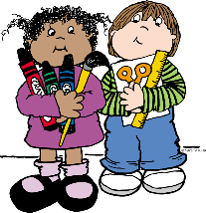

**1 Backpack with child’s name on it**

**2 Pkgs #2 pencils**

**3 Boxes of Crayons (24 count or less)**

**1 Box of thick markers**

**1 Pair of Fiskar scissors**

**20 Glue sticks**

**2 Black & White Primary Composition books**

**2 Boxes of kleenex**

**1 Bottle of Germ X/ Purell Hand sanitizer**

**2 Packages of Baby wipes**

**6 Plastic 3 prong folders w/pockets**

**1 Roll of Paper Towels**

**1 Plastic Pencil Box**

**1 Ream of Copy Paper**

**Wish List Items**

**1 Package of plastic or paper cups**

**1 Package of white paper plates**

**2 Packages dry erase markers**

**2 Boxes of QUART size ZIPLOC bags**

**2 Boxes of GALLON size ZIPLOC bags**

**1 Box of Band-Aids**

**\* Additional supplies may be requested by particular teachers at the beginning of the year.**

**\*\*Please do not label supplies, they are used for the class community.**

**NEW RIVER ELEMENTARY**

**Kindergarten Grade Supply List**