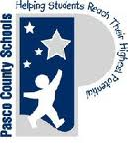
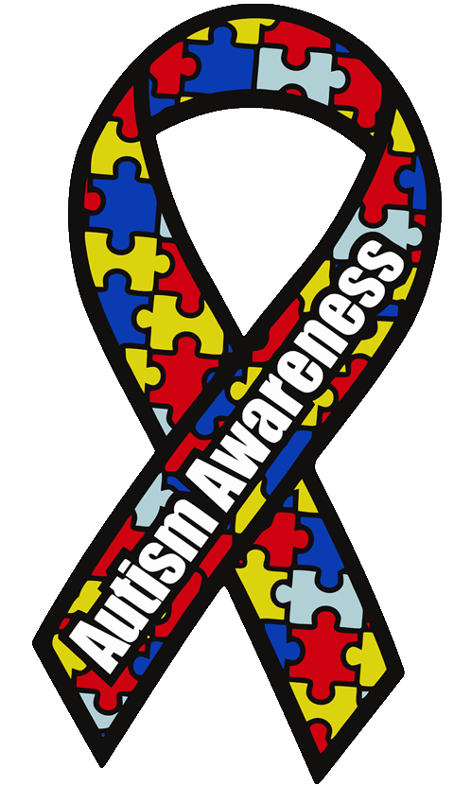
Exceptional Student Extravaganza
&
New River Elementary Autism Walk
April 18, 2015
Come join the fun at New River Elementary as we celebrate our Exceptional Students. This extravaganza benefits all of our NRES Exceptional Students, enabling us to purchase needed technology and materials. At the event you will be able to enjoy some of the following activities:
Bounce Houses Basket Bonanza
Carnival Games Cake Walk
Farmer’s Market (vegetables & more) 5K Foam Walk/Run (Sign-up required)

T-Shirts: $12 pre order or $18 day of event

Schedule for the Day
9:00 am - 5K Foam Run/Walk (Separate sign-up required)
9:30am – 12:00 - Extravaganza Events
12:30pm – Basket Bonanza Prizes Awarded

Hosted By: New River Elementary School & PTA

Games and Bounce Houses are FREE. Tickets will be sold at the event to purchase food, and to participate in the Gift Basket Bonanza, Cakewalk, and Dunk Tank.
For more information call (813) 346-0500 or visit http://nres.pasco.k12.fl.us

Interested in becoming a sponsor, with a product, information booth, or for monetary donations, please contact Jon Leidy (813) 346-0500.

