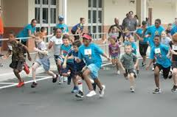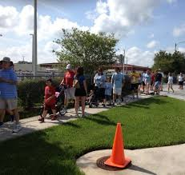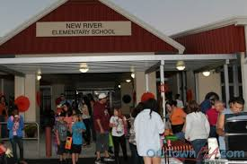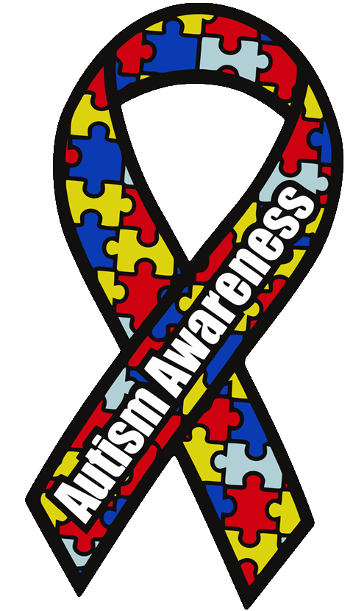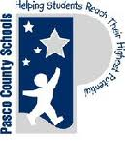

This year students will run in a PTA sponsored

Reptile Kindness Run. Students will get pledges to support them in this run. Run will occur during specials on April 15th. Awards will be presented at 7:45.

**Schedule for the Day**

**During Specials:** Reptile Kindness Run

(Pledge Form optional)

**4:30 – 7:45** Extravaganza Events

**7:45** Reptile Kindness Run Awards Basket

**8:00** Basket Bonanza Prizes Awarded

For more information call (813) 346-0500 or visit <http://nres.pasco.k12.fl.us>

**Interested in becoming a sponsor, with a product, information booth, or for**

**monetary donations, please contact Jon Leidy (813) 346-0500.**

Come join the fun at New River Elementary as we celebrate our Exceptional Students. This extravaganza benefits all of our NRES Exceptional Students, enabling us to purchase needed technology and materials. At the event you will be able to enjoy some of the following activities:

Bounce House Carnival Games / Cake Walk

Farmer’s Market Student STEAM Demonstrations

Basket Bonanza Local Business Vendors

Kindness Run NRES Chorus Performance

Games and Bounce Houses are FREE. Tickets will be sold at the event to purchase food and participate in the Gift Basket Bonanza, Cake Walk, and Dunk Tank.

T-Shirts: $12 pre order or $18 day of event

New River Elementary 4710 River Glen Blvd, Wesley Chapel, FL

Exceptional Student Extravaganza

New River Elementary Autism Awareness Celebration

April 15, 2016

# When: April 15, 2016