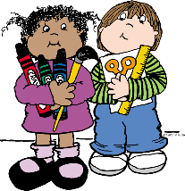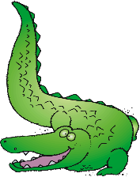

1. **Backpack with child’s name on it (no rolling backpacks)**

**2 Pkg #2 pencils**

**3 Boxes of Crayons (24 count)**

**1 Box of thick markers**

**1 Pair of Fiskar scissors**

**20 Glue sticks**

**4 Black & White Primary Composition books**

**3 Boxes of kleenex**

**1 Bottle of Germ X/ Purell Hand sanitizer**

**2 Packages of Baby wipes**

**3 PLASTIC 3 prong folders w/pockets(1 of each color: blue, orange, green)**

**2 Rolls of Paper Towels**

**1 Box each of GALLON and SNACK size Ziploc bags**

**1 Ream of Copy paper**

1. **Packages EXPO fine line dry erase markers**

**1 Package fine line Crayola markers**

**NEW RIVER ELEMENTARY**

**First Grade Supply List**

**Wish List Items**

**1 Package of plastic or paper cups**

**1 Package of paper plates (large/small)**

1. **Package of Sharpie markers**
2. **Disinfecting wipes**

**1 Box of Magic Erasers**

**\* Additional supplies may be requested by particular teachers at the beginning of the year.**

**\*\*Please do not label supplies, they are used for the class community.**