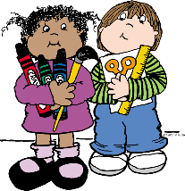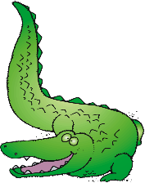

**Wish List Items**

* **Package of plastic or paper cups**
* **Package of white paper plates**
* **Packages dry erase markers**
* **SNACK size ZIPLOC bags**
* **SANDWICH size ZIPLOC bags**
* **Additional ream of copy paper**

**\*Additional supplies may be requested by particular teachers at the beginning of the year.**

**\*\*Please do not label supplies, as they are used for the class community.**

* **1 Backpack (with child’s name in it)**
* **1 Package of #2 pencils**
* **4 Boxes of Crayola crayons (24 count)**
* **1 Pair of blunt Fiskar scissors**
* **20 Glue sticks**
* **2 Boxes of Kleenex**
* **1 Bottle of hand sanitizer**
* **2 Packages of baby wipes**
* **2 Plastic folders with pockets & prongs**
* **1 Roll of paper towels**
* **1 Ream of white copy paper**

**NEW RIVER ELEMENTARY**

**Kindergarten Supply List**