**NEW RIVER ELEMENTARY**

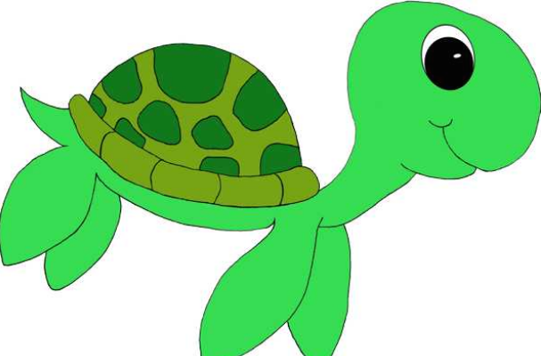1st Grade Supplies

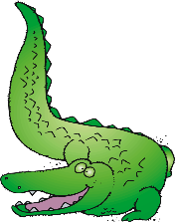

* **Backpack with child’s name on it**
* **2 packs #2 pencils**
* **3 boxes of Crayola crayons**
* **2 reams copy paper**
* **Scissors**
* **10 Glue sticks**
* **Dry erase markers- Fine and thick**
* **Pink pearl erasers**
* **3 Composition notebooks (no spirals notebooks)**
* **3- 3 prong plastic folders (Green, Purple, Blue)**

**Wish List Items**

* **Clorox wipes**
* **Magic erasers**
* **Paper Towels**
* **Box of Quart & Gallon size ZIPLOC bags**
* **Tissues**
* **Crayola Markers**
* **Band-Aids**

**\* Additional supplies may be requested by teachers at the beginning of the year.**

**\*\*Please DO NOT LABEL supplies. They are used for the class community.**

