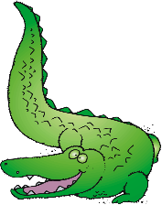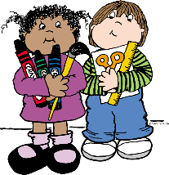

**Wish List Items**

* **Package of plastic or paper cups**
* **Package of white paper plates**
* **Boxes of SNACK size ZIPLOC bags**
* **Boxes of SANDWICH size ZIPLOC bags**
* **Boxes of QUART size ZIPLOC bags**
* **Boxes of GALLON size ZIPLOC bags**
* **Additional reams of copy paper**
* **Treasure Box items (examples: kids meal toys, dollar store toys, gently used small toys)**

**\* Additional supplies may be requested by teachers at the beginning of the year.**

**\*\*Please DO NOT LABEL supplies.**

**They are used for the class community.**

* **1 backpack with child’s name on it**
* **12 glue sticks**
* **4 boxes of Crayola 24 count crayons**
* **3 solid-colored plastic folders with prongs and pockets**
* **1 package of #2 pencils**
* **1 pair of Fiskar blunt-tip scissors**
* **1 package of BLACK dry erase markers**
* **1 box of Kleenex**
* **1 bottle of hand sanitizer with pump**
* **1 package of baby wipes**
* **1 roll of paper towels**
* **1 ream of copy paper**

**NEW RIVER ELEMENTARY**

**2019-20 Kindergarten Supply List**