Installing Smarty Ants, Zoom and Other Apps on iPads

For iOS Devices (iPads) managed by Pasco County Schools please follow these steps:
- Launch the Self Service app

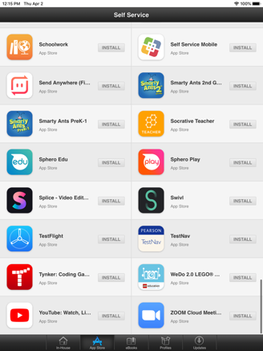
- Scroll down the alphabetized list and locate the app you would like to install EX: ‘smarty ants’ or ‘zoom’

- Select the app and click Install

- Once you have installed all of the appropriate apps, launch the ClassLink app
  - If ClassLink Launchpad is not correctly configured for Pasco County Schools use the ‘Search for your school district’ field and type in ‘Pasco’
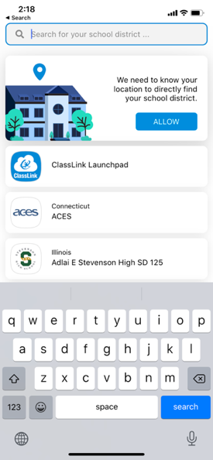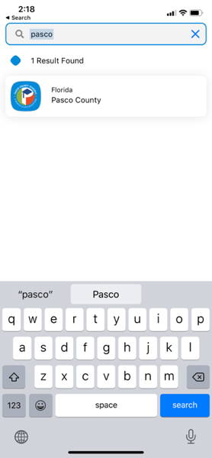

Installing Smarty Ants, Zoom and Other Apps on Personal Devices

For Personal devices managed by you please follow these steps (pictures are from an iOS device):
- Locate the App Store on your device

- Launch the App Store and search for the applications you would like to install EX: ‘smarty ants’ or ‘zoom’ or ‘classlink’
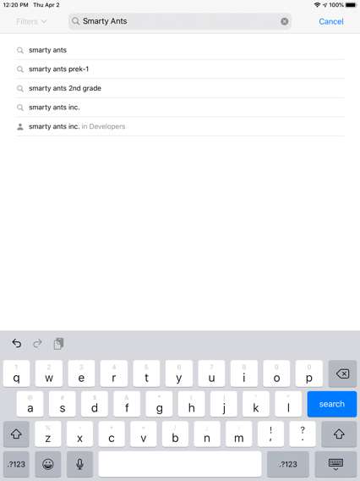
- Click the ‘Get’ button and sign in with an Apple ID (on an iPad) to start the install
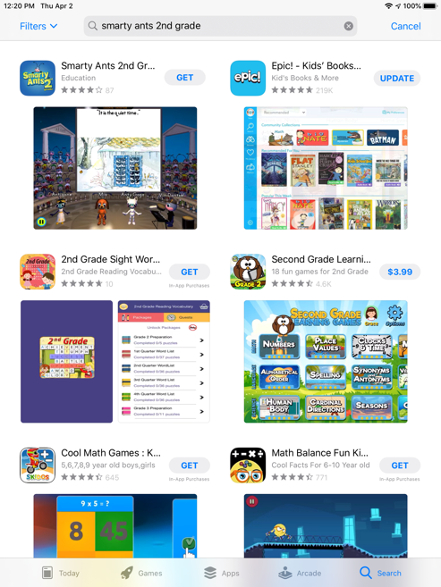
- Once the appropriate apps are installed, launch the ClassLink application
  - As the ClassLink app will not come in configured for Pasco County Schools use the ‘Search for your school district’ field and type in ‘Pasco’
