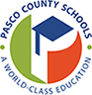

Dear Parents/Guardians:

All students in grade Pre-K through 2nd grade will have access to SmartyAnts® as a part of their weekly digital learning routine. The SmartyAnts® literacy program will support our students as they continue to develop as readers from home. It combines foundational skills instruction, independent practice, and embedded assessments. Students will spend 15 to 20 minutes, 3 or 4 days a week using SmartyAnts® to continue to practice their foundational skills and develop as readers. This program is adaptive and responds to students where they are in their foundational skill development.

Information regarding iPad and computer systems requirements click [here](https://livepascok12fl.sharepoint.com/:b:/s/OTIS_Resources/EUaYPkK400BApx45NjzX9ZgB2EbQLGYEJuYxGGhBhL5zlQ?e=WSBQ7P).

Students will access SmartyAnts® on their myPascoConnect dashboard.

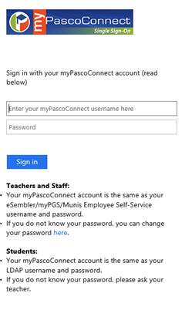Username: Student ID/Lunch # (ex. 123456)  
Password: myPascoConnect Password (ex. Stars21#)

If you have any questions, please feel free to call or email our support team at [support@achieve3000.com](mailto:support@achieve3000.com) or 877-235-2525.