New River Elementary
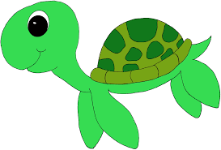
1st Grade Supply List

Face to Face Model

- Backpack with child’s name on it
- Pencil box (Labeled)
- 1 pack #2 pencils
- 2 boxes of Crayola crayons
- Scissors
- 10 Glue sticks
- Dry erase markers- Fine and thick
- Pink pearl erasers
- 3 Composition notebooks (no spirals notebooks)
- 3- 3 prong plastic folders (Green, Purple, Blue)
- Ear phones/Ear buds (labeled)

Wish List Items
- Clorox wipes
- Paper Towels
- Box of Quart or Gallon size ZIPLOC bags
- Tissues
- Crayola Markers
- Band-Aids

* Please preload the following supplies into your child’s labeled pencil box:
-Pencils (4/5 sharpened)
-1 eraser
-1 box of crayons
-scissors
-1 glue stick
-1 thin dry erase marker

MySchool Online Model
- Pencil box
- Pencils
- Pencil sharpener
- Scissors
- Crayons
- Glue sticks
- Dry erase markers- Fine
- 3 composition notebooks
- 1 folder
- Ear phones or Ear buds
- Organization for school supplies
- Quiet workplace

*Families will need to replenish home supplies as needed

*Families may need to provide additional supplies if transitioning back to the traditional face to face model

