New River Elementary
2nd Grade Supply List

Face to Face Model

- Backpack with child’s name on it
- Pencil box (Labeled)
- 2 pack #2 pencils
- 2 boxes of Crayola crayons
- Scissors (Labeled)
- 4 Glue sticks
- 4 Expo dry erase markers
- 2 Pink pearl erasers
- 3 Composition notebooks, black and white (no spirals notebooks)
- 4 highlighters

- 6 - 3 prong plastic folders
(1 Blue, 1 red, 1 green,
1 yellow, 2 others of your choice)
- Ear phones/Ear buds (labeled)
- 1 Roll of paper towels
- 1 pack of Lysol or Clorox wipes
- 2 Boxes of tissues
- Change of clothes in Ziploc bag with child’s name.

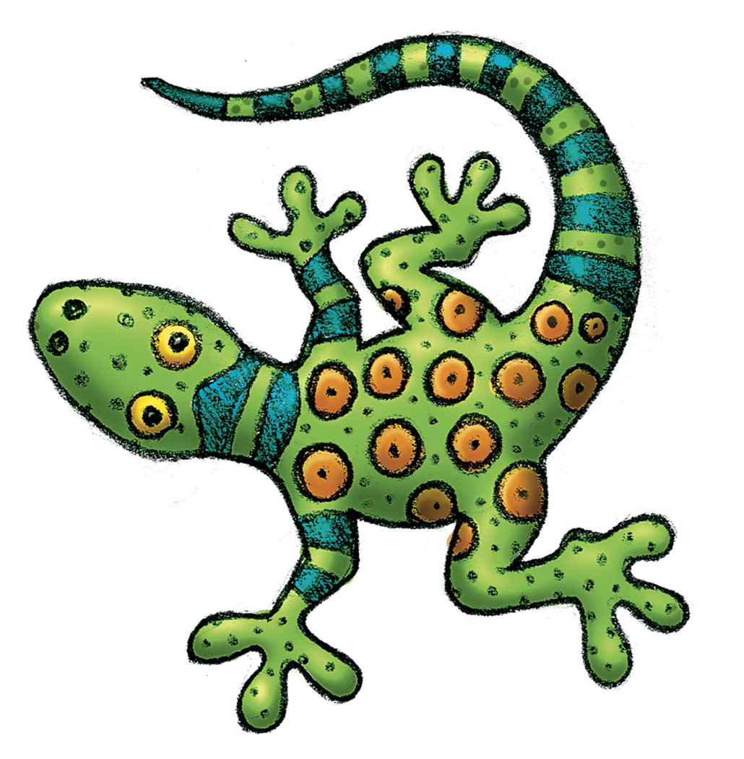
Wish List Items
- Box of Quart or Gallon size ZIPLOC bags
- 3x3 Post Its
- 1 package of index cards
- 1 package of fine tip dry erase markers
- 1 bottle of hand sanitizer
- I package of magic erasers

* Please preload the following supplies into your child’s labeled pencil box:
-Pencils (4/5 sharpened)
-1 eraser
-1 box of crayons
-scissors
-1 glue stick

MySchool Online Model
- Pencil box
- Pencils
- Pencil sharpener
- Scissors
- Crayons
- Glue sticks
- Dry erase markers- Fine
- 3 composition notebooks
- 1 folder
- Ear phones or Ear buds
- Printer access
- Quiet workplace

*Families will need to replenish home supplies as needed

*Families may need to provide additional supplies if transitioning back to the traditional face to face model

