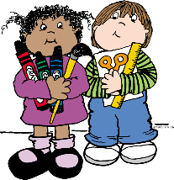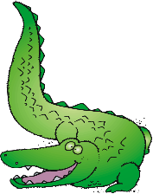

* **1 backpack with child’s name on it**
* **1 pencil box**
* **2 glue sticks**
* **4 boxes of Crayola 24 count crayons**
* **3 solid-colored plastic folders with prongs & pockets**
* **1 pair of Fiskar blunt-tip scissors**
* **I pair earbuds/headphones**
* **1 package of BLACK dry erase markers**

**(chisel tips)**

* **1 package of BLACK dry erase markers**

**(fine point tips)**

* **1 box of Kleenex**
* **1 bottle of hand sanitizer with pump**

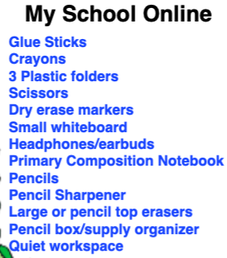

**Wish List Items**

* **Paper Towels**
* **Disinfecting wipes**
* **ZIPLOC bags (any size)**
* **Treasure Box items (examples: kids meal toys, dollar store toys, gently used small toys)**

**\* Additional supplies may be requested by teachers at the beginning of the year.**

**NEW RIVER ELEMENTARY**

**2020-21 Kindergarten Supply List**