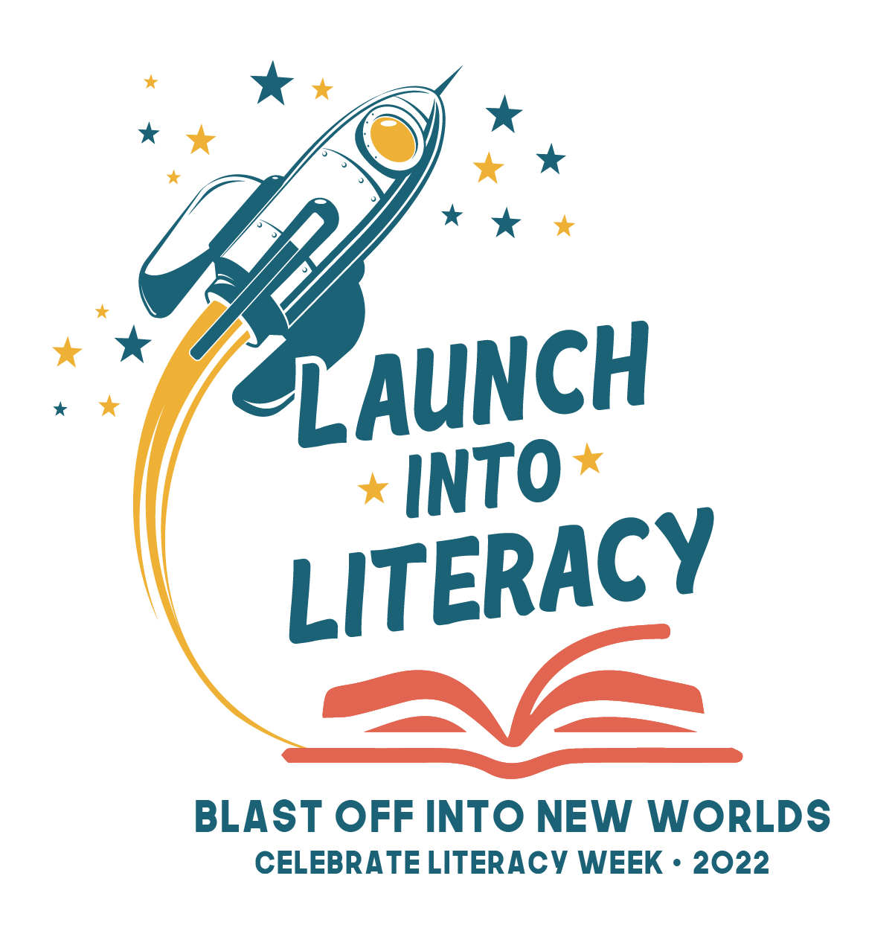

Celebrate Literacy Week, Florida!
January 24th-28th, 2022
#LaunchIntoLiteracy

We are excited to Celebrate Literacy this week alongside you. Please share your celebrations too on Twitter and be sure to tag: #PascoLiteracy, @PascoLiteracy,#FLCelebratesLiteracy, and @EducationFL

Date to Celebrate | Blasting Off into New Worlds | Theme | Activity
Monday, January 24th | Space  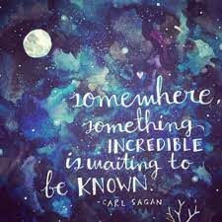  Computer Science  Space Talk: Launch into Scratch coding  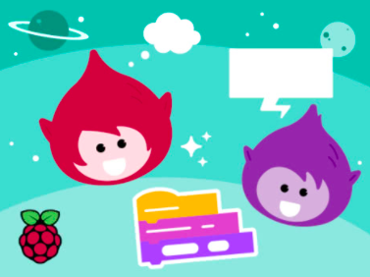 | Mission Monday | “One small step for man, one giant leap for mankind”  - Read a book about saving our planet  - Blasting off into space can be bright. Wear sunglasses and brightly colored attire.  - CS- Create a space scene with characters that 'emote' to share their thoughts or feelings using sounds, colors, and actions. https://hourofcode.com/raspispace
Tuesday, January 25th | Environmental Science  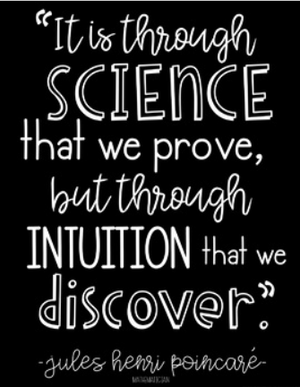 | Tuesday #Trashtag | - Share a photo and/or a good read to help raise awareness and encourage others to do good for the planet.  - Wear green for Going Green!  - Recite the Reader’s Oath
Wednesday, January 26th | Biology  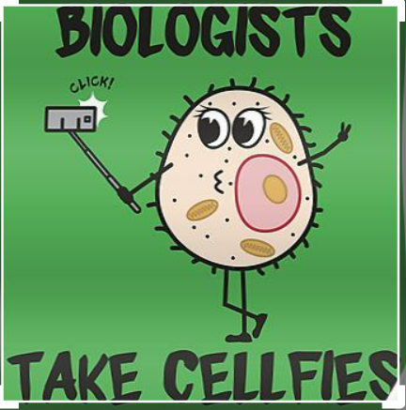 | Wild About Reading | “Houston, we have a problem”  - Read a mystery Or Read a scientific text to complete a science experiment  - Go wild about reading. Wear your favorite animal print or attire.
Thursday, January 27th | Literacy  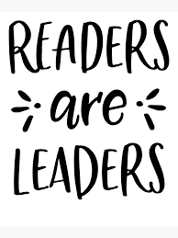 | Leaders are Readers | Hidden Figures  - Read a biography about someone in science, space, engineering, or math  - Students tweet your favorite book titles and/or quotes.  - Wear red and be “Well Read”!
Friday, January 28th | Technology  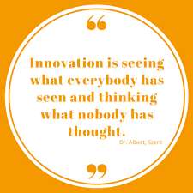 | Crocs and Socks | Technology made both Crocs and socks possible  - Share a photo and tell us the most interesting part of the design of socks and/or Crocs.  - Wear your favorite Crocs and/or socks.

